**1.7 ML and Computer Vision for Developmental Disorders**

Prof Guillermo Sapiro

**Challenges in disorders:**

* Autism: 1:42
  + One every 50, 2% of population
* Sub Saharan/ Africa:
  + 0.5 billion of children, only handful of doctors trained for autism
* Lacks of autism specialists in US
  + Outside of cities
* Behavioral assessment – observation
  + Expensive
  + Time-consuming
    - Hours
  + Not enough clinicians
  + Current standard of care still challenging
    - Screening != diagnosis
      * M-CHAT-R
    - Screening: 50% of false positives
    - Diagnosis: not perfect

**AWS Autism video:**

* <https://www.youtube.com/watch?v=YQpTlnWYAqE>
* Clarification:
  + 17 points in IQ –
  + Between 18 to 24 months
    - US average age of diagnosis is 3 year
    - 3 times: Intervention opportunity missed

**Encoded behaviors**

* Events in the movie are deliberate
* Recording:
  + facial expression(emotions)
  + movement of children
    - Head (turn and pose) and hands movement
  + Audio
  + Clinical data
* Parents are not involved
* Also measuring: Clinician calling the name to tested child
  + Response to name calling
    - <https://acamh.onlinelibrary.wiley.com/doi/abs/10.1111/jcpp.13381?campaign=wolearlyview>

¡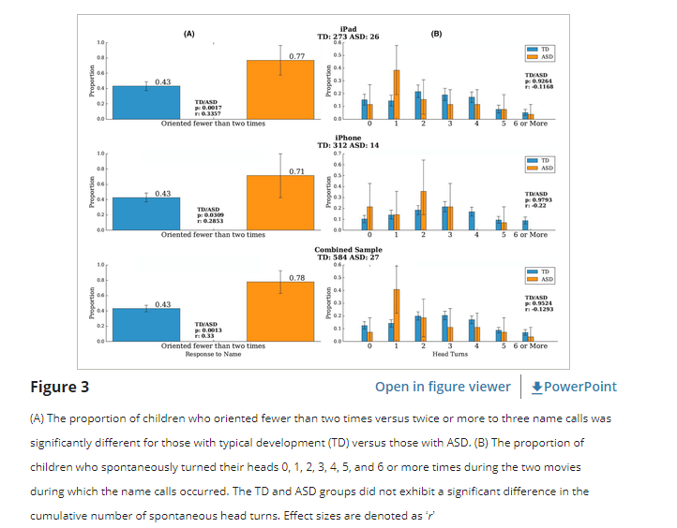

* + - Children with autism will have slower response to name calling
    - Language delay without autism with no significant differences to non-autistic children
* Not easily compliant subjects
* Two categories of biomarkers:
  + Labsetting Biomarkers: reported in literatures, not done in domestic settings but at clinical settings
    - In regular settings
  + Discovery biomarkers:
    - Expert opinion: Distracted child will response to name calling from their parents
      * Thus including at part of the model

**Response to Name Calling**

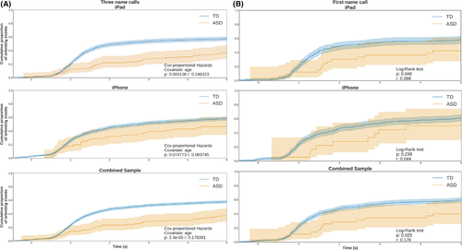

* Face position:
  + Autistic children typically turn at 1 second later than non-autistic children
  + Never observed before in previous studies
  + New Biomarker
* Potential hypothesis:
  + Neural science behind autism: motor effort affecting autism?

**Scalable Gaze Analysis**

* <https://jamanetwork.com/journals/jamapediatrics/fullarticle/2779395>

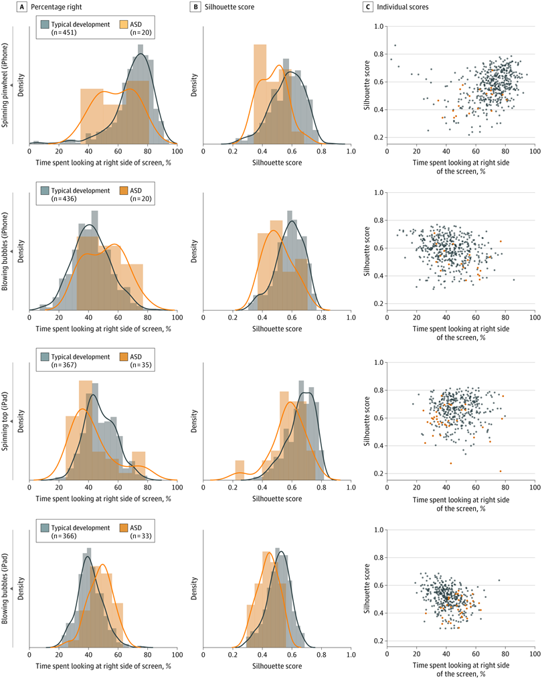

Fig 1. Gaze data for 4 movies that depicted a person on one side of the screen playing with toys located on the opposite side of the screen. A, Distribution of percentage right scores (percentage of time spent looking at the right side of the screen) for each movie. B, Distribution of silhouette scores for each movie. C, Scatterplots displaying individual participant percentage right (horizontal axis) and silhouette scores (vertical axis). For “spinning pinwheel” (iPhone), the person is on the right side of the screen; for “blowing bubbles” (iPhone), the person is on the left side; for “spinning top” (iPad), the person is on the right side; and for “blowing bubbles” (iPad), the person is on the left side. ASD indicates autism spectrum disorder.

* Strong biomarker with glaze
* Potentially lead to motor efforts
* Traditionally under controlled settings
  + Three types of stimuli for left and right motions
    - Alternating conversation between two people at two ends of the screen
      * Ask if children engaged to the left-right pattern for the conversation
      * Autistic children not highly correlated to the conversation
    - Objects gazing
      * Non-social objects gazing well-known as sign of diagnosis than social event
      * Half of the screen containing only the toy
      * Autistic children spend more time gazing at the toy

**Facial Dynamics**

* <https://ieeexplore.ieee.org/document/7021907>
* 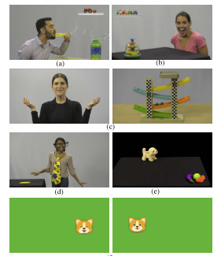
* Facial recognition and expression were originally trained for adult data
  + Not applicable to children data
* Multiscale entropy for dynamics of
  + Eyebrows
  + Mouth
  + 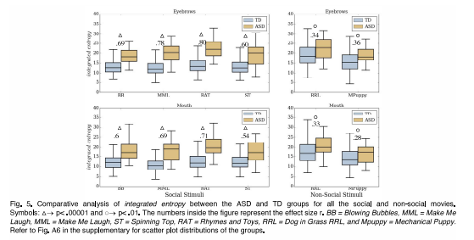
* Much more limited separation in non-social stimuli than social stimuli
  + Less predictable dynamics for autistic children in facial dynamics

**Game: Fine Motor Control**

* <https://www.researchgate.net/publication/351351985_ASSESSMENT_OF_MOTOR_SKILLS_VIA_A_TABLET-BASED_GAME_IN_YOUNG_CHILDREN_WITH_AUTISM_SPECTRUM_DISORDER>
* Carefully designed interactive game
* Bubbles rising from bottom to the top
  + Incentive (nice animal appearing) if popping bubble
  + Recording fine motor control
* Two groups:
  + Autism + ADHD
  + Autism
  + Separating Autism to Autism + ADHD children
    - Autistic children pop more than ADHD children
    - Autistic children with lower accuracy
      * Motor control
    - Number of touches with higher error with ADHD

**Food Intake Disorders**

* <https://onlinelibrary.wiley.com/doi/epdf/10.1002/eat.23639>
* 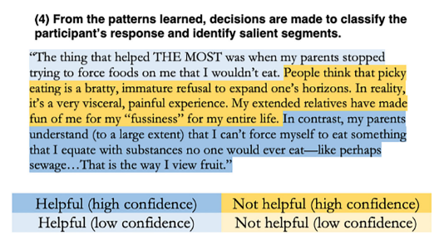
* NLP analyzing responses
  + Positive and negative that may lead to FID
* No known-strategies for all cases
  + Intervention introduced

**ML Challenges**

* Fairness - ICML, FaaCT
  + Questions may not be addressed by ML community
  + Pareto mean mark fairness (possibly referring to Fairness With Minimal Harm)
    - <https://www.ncbi.nlm.nih.gov/pmc/articles/PMC7912461/>
    - <https://par.nsf.gov/servlets/purl/10167731>
    - Fair towards all demographics without hurting another demographics
* Privacy - ICML
* Multimodal missing data
  + Connecting all biomarkers
  + Large number of missing data
    - How to deal with that by ourselves?
* Unique population
* Hard working environment
  + Logistics and technical challenges
* Evaluated by clinicians
  + More publications on clinical journals, not ML journals